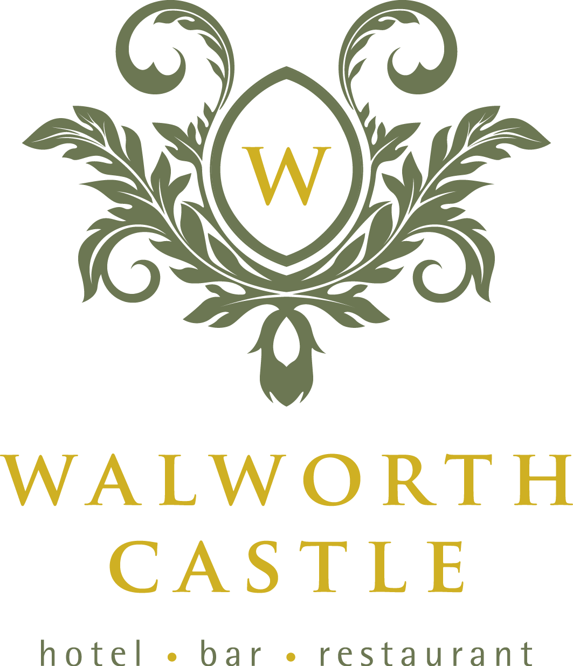

Our principles:
We recognise that we must integrate our business values and operations to meet the expectations of our customers, employees, suppliers, the community and the environment.
We recognise that our social, economic and environmental responsibilities are integral to our business. We aim to demonstrate our commitment to these responsibilities through our actions and within our corporate policies.
We take seriously all feedback that we receive and, where possible, maintain open dialogue to ensure that we fulfil the requirements outlined within this policy.
The management team are responsible for the implementation of this policy and will make the necessary resources available to realise our corporate responsibilities. The responsibility for our adherence to this policy rests with all employees throughout the company.

Our hotel focus:
We will strive to improve our environmental performance through implementation of our sustainable development and environmental policies. We are committed to finding ways in which we can reduce the impact of our work to help the environment. We recycle and reuse wherever possible. We work with our suppliers to reduce waste to benefit the hotel and community. We are assessed by Green Tourism and have been awarded silver status.
We will encourage dialogue with local communities for mutual benefit, and support and encourage our employees to help local community organisations and activities in our region. We work with local charities and organisations including the local scouts who use the grounds for events and fundraising.
We will operate an equal opportunities policy offering our employees clear and fair terms of employment and providing resources to enable their continual development.

We will maintain systems for employee consultation and business involvement.
We will provide safeguards to ensure that all employees are treated with dignity and respect and without harassment.
We will provide, and strive to maintain, a clean, healthy and safe working environment.
We will uphold the values of honesty, partnership and fairness in our relationships with all customers, employees and the community.
Our contracts will clearly set out the agreed terms, conditions and the basis of our relationship.
We will operate in a way that safeguards against unfair business practices.
We will encourage suppliers and contractors to adopt responsible business policies and practices for mutual benefit.

