1189 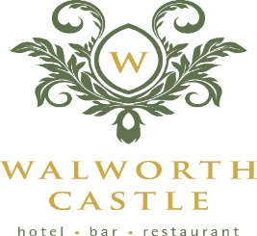
Bar & Kitchen
SUNDAY LUNCH MENU

TO START

Soup of the day served with rustic roll (v, gf) £6.50

Fried somerset brie with stewed grapes and beetroot slaw (v) £6.50

Grilled black pudding served with hash brown , bacon and mustard mayo £6.50

Classic prawn cocktail with shredded iceberg – tomato -cucumber – Marie rose sauce – bloomer bread £6.50

Duck and pork pate served with plum and apple chutney – toast £6.50

Chicken tikka salad – mango – poppadom – naan £6.50

To follow

All served with a selection of vegetables and potatoes, jug of gravy – Yorkshire pudding

Roast beef and Yorkshire pudding – horseradish sauce £16.95

Roast pork and stuffing – apple sauce £15.95

Roast turkey and stuffing cranberry sauce £15.95

Roast lamb and mint sauce £16.95

Castle fish pie - cod – salmon – prawns – mash and cheddar topping £16.95

Wild mushroom and spinach pasta with truffle oil and parmesan (v) £14.95

Vegetarian roast dinner £14.95 (v)

SIDE ORDERS
Cauliflower Cheese
6 Pigs in Blankets
Roast Potatoes
Yorkshire Pudding
All £4.00 Each

to end

Sticky toffee pudding served with rum and raisin ice cream and ginger crumb (v) £6.50

Chocolate Brownie – Coconut Ice Cream – Berries (V) GF £6.50

Apple and Berries Crumble served with Vanilla Custard (V) £6.50

Lemon Posset served with Meringue and Shortbread (V) £6.50

Selection of Cheese and Biscuits £11.00

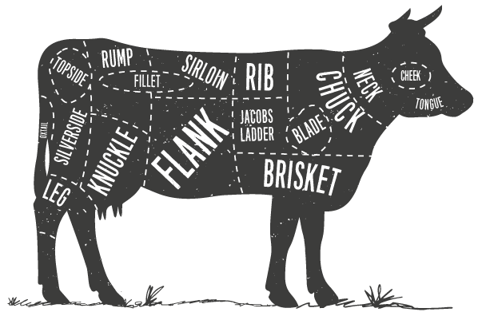

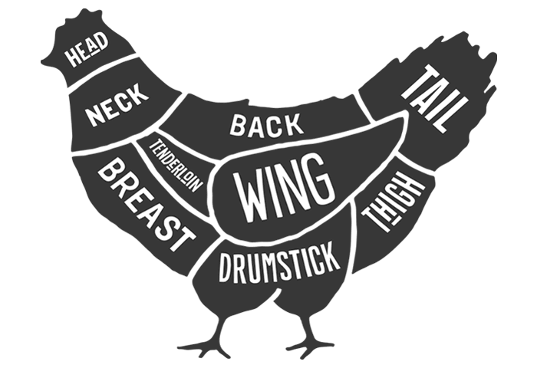

If you have any food allergies. Please let a member of staff know and we will be happy to cater for you –(v – vegetarian/VE -vegan/GF – Can be made Gluten Free on Request

