1189 Bar & Kitchen Menu

Breads

Rosemary Focaccia with Melted Garlic Butter and Cheese (V) - £5.00

Flat Bread with Red Pepper Hummus and Marinated Grilled Vegetables (VE) - £6.00

To Start – To Share – To Graze

Soup of the Day - £6.50
Served with Rustic Bread (GF)

Wholetail Scampi - £8.00
Served with Truffle Mayo and Crispy Salt and Pepper Cabbage

Tandoori Chicken Skewer - £8.00
Served with Mint and Coriander Yoghurt, Mango Chutney and Popadom Shards (GF)

Sticky Kung Pao Cauliflower Bao Bun - £8.00
Served with Coriander, Spring Onion and Cashew Salad (VE)(N)

Black Pudding and Hash Brown Stack - £8.00
Served with Black Pepper Mayo and Pancetta

Patatas Bravas - £7.00
Served with Tomato, Aioli and Parmesan (V)(GF)

From The Grill

21 Day Aged 10oz Ribeye Steak (GF) - £25.95

Trio of Minted Lamb Cutlets (GF) - £23.00

Grilled 10 oz Gammon Steak – (GF) - £19.00

All Steaks are served with Proper Homemade Chips, Field Mushroom, Tomato and Onion Rings

IF YOU HAVE ANY FOOD ALLERGIES, PLEASE LET A MEMBER OF STAFF KNOW AND WE WILL BE HAPPY TO CATER FOR YOU – (V- VEGETARIAN /VE – VEGAN – GF – CAN BE MADE GLUTEN FREE ON REQUEST) / (N) – CONTAINS NUTS
OUR FOOD IS PREPARED IN A KITCHEN WHERE NUTS, CEREALS AND OTHER ALLERGENS ARE PRESENT.

Main Courses

Slow Cooked Beef Cheek Puff Pastry Pie - £20.00
Served with Cauliflower Cheese, Chips and Buttered Toasted Breadcrumbs

Chip Shop Treats - £19.00
Beer Battered Cod Goujons, Battered Sausage, Curry Sauce, Pickled Onion, Tartar Sauce and Chips

Tandoori Mixed Grill - £25.00
Lamb Shish, Chicken Tikka, Garlic King Prawns, Onion Bhajis, Naan Bread, Poppadom, Mango, Garlic Dip and Fries

Panko Fried Chicken or Marinated Cauliflower Bang Bang - £18.00
Sesame and Coconut Rice, Naan Bread, Popadom (VE)(Sesame Seeds)

Creamy Peppered Pork Loin Steaks - £19.00
Served with Green Vegetables and Sauteed Potatoes (GF)

Chicken Milanese - £18.00
Garlic and Mushroom Rigatoni

Castle Burger - £18.00
Served with Bacon, Brie, Chilli Jam, Truffle Mayo, Tomato, Lettuce, Skinny Fries, Onion Rings and Coleslaw (GF)

Pathia Paneer Curry - £17.00
Served with Basmati Rice, Naan Bread, Popadom (VE) (GF)

Roast Belly Pork - £19.00
Served with Black Pudding Mash, Seasonal Vegetables and Cider Sauce (GF)

Deep Fried Wholetail Scampi - £18.00
Served with Chips, Salad, Tartar Sauce and Lemon

On The Side

Six BBQ Chicken Wings with Blue Cheese Dip - £8.00

Six Hot and Spicy Chicken Wings with Hot Sauce Dip - £8.00

Salt and Pepper Skinny Fries (VE) - £4.50

Beer Battered Onion Rings (V) - £4.50

Four Cheesy Garlic Bread Slices (V) - £4.50

IF YOU HAVE ANY FOOD ALLERGIES, PLEASE LET A MEMBER OF STAFF KNOW AND WE WILL BE HAPPY TO CATER FOR YOU – (V- VEGETARIAN /VE – VEGAN – GF – CAN BE MADE GLUTEN FREE ON REQUEST) / (N) – CONTAINS NUTS
OUR FOOD IS PREPARED IN A KITCHEN WHERE NUTS, CEREALS AND OTHER ALLERGENS ARE PRESENT.

To End

Cheeseboard - £10.00
Wensleydale and Cranberry, Blue Stilton and Mature Cheddar
Served with Crackers, Plum and Apple Chutney

Sticky Toffee Pudding (V) - £8.00
Served with Butterscotch Sauce and Rum and Raisin Ice Cream

Potted Meringue (V) - £8.00
Lemon Curd, Mascarpone Cream, Berries and Honeycomb

Black Cherry Bakewell Tart (N) - £8.00
Served with Cherry and Custard Ice Cream

Chocolate Nemesis (V)(GF) - £8.00
Served with Orange Jelly and Chocolate Orange Ice Cream

Deep Fried Churros (V) - £8.00
Served with Cinnamon Sugar and Chocolate Sauce

Three Scoops of Ice Cream or Sorbet - £6.50
Choose from the Following:

Ice Creams (GF)

Chocolate
Strawberry
Vanilla
Mint Chocolate Chip
Rum and Raisin

TOPPINGS (GF) (VE)

CRUNCHY BITES
CADBURY CHUNKS
CHOCOLATE SAUCE
RASPBERRY SAUCE

Sorbets (GF) (VE)

Raspberry
Lemon
Mango

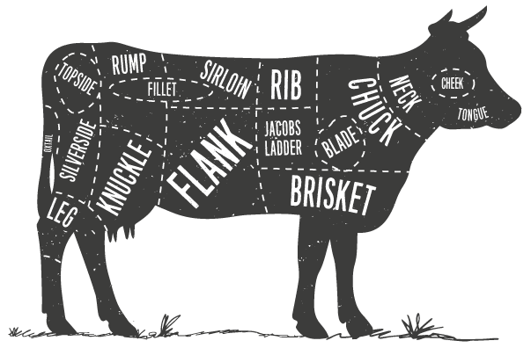

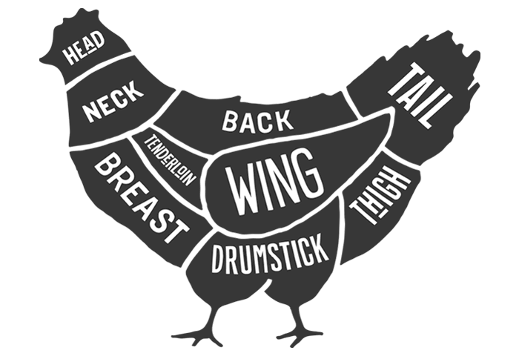

IF YOU HAVE ANY FOOD ALLERGIES, PLEASE LET A MEMBEROF STAFF KNOW AND WE WILL BE HAPPY TO CATER FOR YOU – (V- VEGETARIAN /VE – VEGAN – GF – CAN BE MADE GLUTEN FREE ON REQUEST) / (N) – CONTAINS NUTS
OUR FOOD IS PREPARED IN A KITCHEN WHERE NUTS, CEREALS AND OTHER ALLERGENS ARE PRESENT.

